CHAPTER 3 PROJECT – ALGEBRA TILES

- You will be given a sample algebra tiles that you can cut out.
- You will have to pick 2 expressions (1 form of x²+bx+c and 1 form of ax²+bx+c) and use these tiles to form it. You cannot have the same expressions with your classmates or you will loose marks.
- You can color or design your algebra tiles if you like or transfer it to a colored paper. You can use computer if you prefer.
- Your final answers with the cut-outs should be glued in an A4 paper.
- Mark = 20 marks
- Deadline : Nov. 25, 2013 , 5:00 pm

Example Output

Name: Nero Zou Class: 10B Mark: _____/20

CHAPTER 3 – ALGEBRA TILES PROJECT

Expression Factors Algebra Tiles

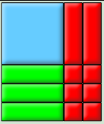
x²+5x-6 (x-3) (x+2)

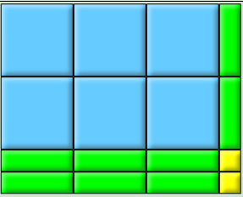
6x² ⁺ 8x+ 2 (3x+1) (2x+2)

